QNB Finansbank to install 200 units of Hitachi’s cash recycling ATM SR7500
Hitachi-Omron Terminal Solutions to enter the Turkish ATM market with Protem

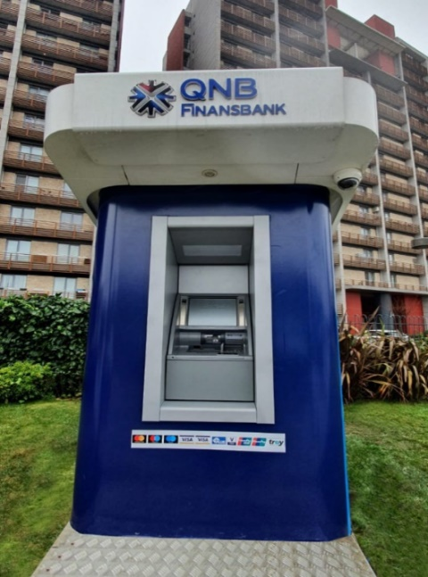
Hitachi Cash Recycling ATM (SR7500)

Tokyo, April 26, 2021 --- Hitachi-Omron Terminal Solutions, Corp. (Hitachi-Omron Terminal Solutions) today announced that QNB Finansbank (Finansbank) – a leading retail bank in Turkey - has begun installation of Hitachi's Cash Recycling ATM, SR7500.
While financial institutions are pursuing a higher-level of work efficiency, Cash Recycling ATMs (which provide automated deposit ATMs with cash recycling technology) are expected to be a future standard of ATMs. By using deposited cash for future dispensing transactions, Cash Recycling ATMs provide minimized cash transportation cost and optimal cash operation for financial institutions. Hitachi-Omron Terminal Solutions is a leading manufacturer in cash recycling ATMs which requires high level of sensing and mechatronics technologies to process currency. Now, over 207,000 units of cash recycling ATM are installed all over the world.

Hitachi-Omron Terminal Solutions provides Cash Recycling ATMs via its Turkish distributor Protem Electronics Machinery Industry and Trade Inc., (Protem). The proven quality of Hitachi-Omron Terminal Solutions ATMs, as well as the undisputed reputation of the field service offered countrywide by Protem, were the main factors behind QNB Finansbank’s decision to choose Hitachi-Omron Terminal Solutions ATMs. As a result of this deal, there is now a new player in the ATM industry in Turkey.
Protem represents some of the word’s leading manufacturers and offers products and services that address all needs in the entire life cycle of cash, in the form of machines and systems for processing of banknotes, coins, and cheques.
Together with its Turkish partner, Protem, Hitachi-Omron Terminal Solutions aims to contribute to achieving a safer and more secure society, through additional expansion of its high performance and reliable Cash Recycling ATMs.
Comment from Cem Binerer, Sales Director of Protem:
“We are delighted to offer ATMs with state-of-the-art technology to the banks in Turkey, combining Hitachi’s worldwide experience with Protem’s power in the local market. This will enable banks to both increase customer satisfaction whilst minimizing their ATM costs. Our target is to replicate our leadership in the local market to the ATM industry in the medium term.”
Comment from Masato Sawaragi, Operating Officer and General Manager Global Business Group of Hitachi-Omron Terminal Solutions:
"It is a great honor for Hitachi that Turkey’s major commercial bank, Finasbank has chosen our cash recycling ATMs. We consider Turkey as one of the most promising markets for cash recycling ATMs in the world. As a leading manufacturer of Cash Recycling ATMs, Hitachi-Omron Terminal Solutions would like to contribute to creating a safer and more secure banking system in Turkey."

About Protem Electronics Machinery Industry and Trade Inc.
Protem, founded in 1993 and currently headquartered in Istanbul, has proven expertise in banking and cash industry that made the company the market leader in its field. Protem’s scope of business is to sell, service and develop machinery and systems related to the production, processing and packaging of banknotes, coins and cheques. The Company is capable of providing 24/7 on-site technical support services for around 40,000 machines of different types with its service organization, including specialized and qualified field technicians operating all over Turkey. PROTEM enjoys the support of its in-house software development team to adopt its services to the diverse and evolving requirements of the industries it serves.
For more information about Protem Electronics Machinery Industry and Trade Inc., Co, please visit:
www.protem.com.tr

About Hitachi-Omron Terminal Solutions
Hitachi-Omron Terminal Solutions, headquartered in Tokyo, Japan, is a member of the Hitachi Group and a leading vendor of cash recycling ATMs in the world. Hitachi-Omron Terminal Solutions provides highly reliable ATMs and bank systems that address real user needs. The company supports a secure, safe, and comfortable society through our prominent technologies and innovative solutions.

For more information about Hitachi-Omron Terminal Solutions, please visit:
https://www.hitachi-omron-ts.com/

For inquiries regarding this matter, please visit:
https://www8.hitachi.co.jp/inquiry/hitachi-omron-ts/general/en/form.jsp

# # #

